bc  

**MEMO Number: CMPE320_S21_005**

**DATE: 05/16/2021**

**TO: EFC LaBerge and CMPE 320 Peers**

**FROM: Nem Negash**

**SUBJECT: Project 5: Autocorrelation in Random Processes**

# introduction

The purpose of this project is to investigate autocorrelation of a random signal. For this project, we will be using the MATLAB function xcorr to simulate the correlation of the random variables.

# analysis

## Create a MATLAB Model

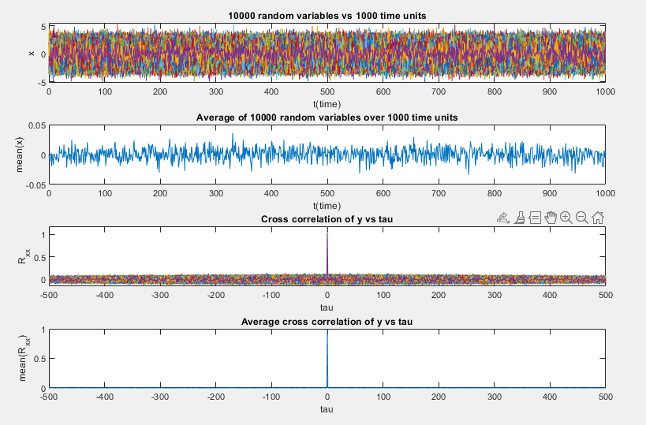

Figure : Plots for 1000 random variables and cross correlation of them

The first plot in **Figure 1** shows the random variables generated for 1,000-time units with 10,000 trials. The plot shows a rainbow of line plots that represent each of the 10,000 trials. The second plot is the average of the first plot. This plot shows the average random variable for each time unit. This third plot is the shows the random variables compared using the MATLAB autocorrelated function xcorr which shows a spike up to 1 when tau equals 0. This is because since tau is 0 the random variables shifted by tau are the same as the random variables of the randn MATLAB function. The fourth plot shows the average of the third plot. It represents the average correlation for a given tau value.

## Simulated Filtered Random Gaussian Data

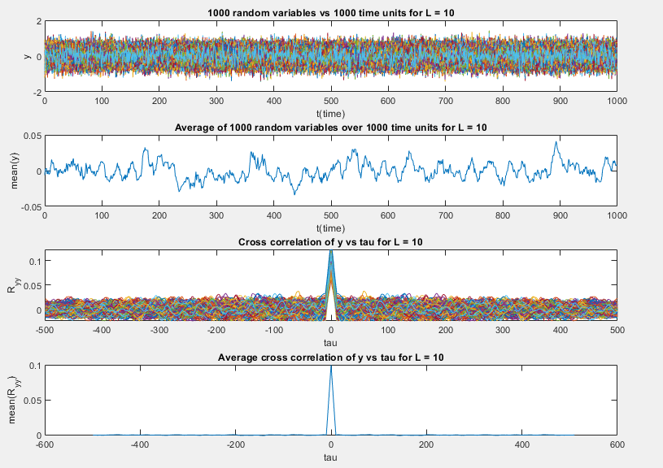

Figure : Plots for 1000 random variables and cross correlation of them where Length = 10

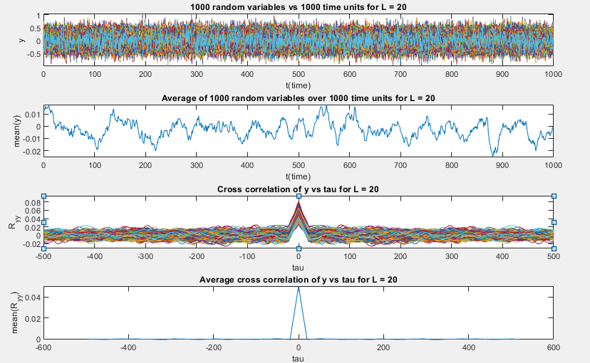

Figure : Plots for 1000 random variables and cross correlation of them where Length = 20

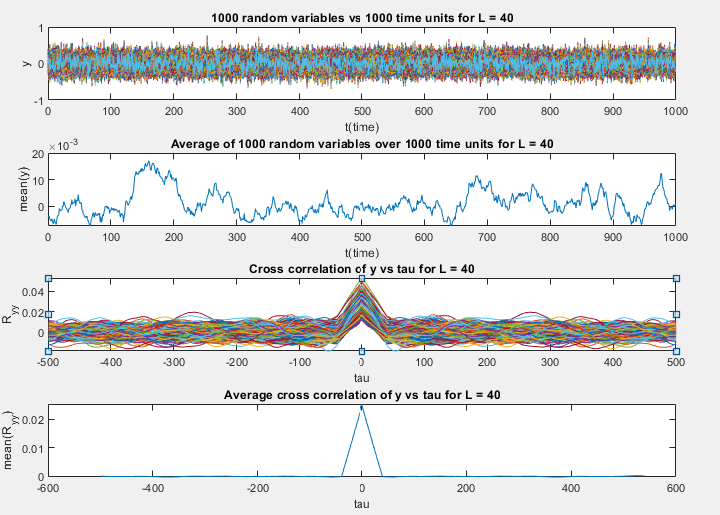

Figure : Plots for 1000 random variables and cross correlation of them where Length = 40

**Figure 2-4** shows the same plots from the previous section with a sliding window average of [10,20,40]. The first plot for each figure shows the randomly generated variables for a for 1,000-time units with 1,000 trials. The second plot is the average of the first plots which the is just the average of random variables for each time unit. The third plot shows a plot similar to the third plot in the previous section with a little change. The third plots in this section have a triangular shape near then center where tau = 0. This is because the random variables are being shifted not just by tau anymore but also by the sliding window factor. While the peak of the third plot decrease as the sliding window factor increases the area of the triangle (which would be the integral) would still be approximately 0. The fourth plot shows the average of the third plot. It represents the average correlation for a given tau value.

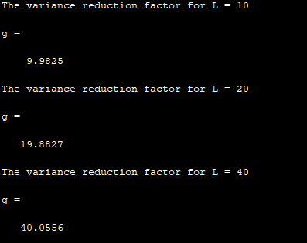

Figure : The variance reduction factor for each value of Length (sliding window factor).

**Figure 5** shows the variance reduction factor for each given sliding window factor. This was calculated by dividing the max value of the R_XX array by the max value of the R_YY array.

# What I learned

This project has really given me a much better understanding of Autocorrelation in Random Processes. It’s interesting to see how autocorrelation and cross-correlation are used for measuring the similarities of signals in subject like pattern recognition and signal detection. This project has also expanded my understanding of MATLAB functions by using functions such as xcorr and the different types of files MATLAB provides such as scripts and live scripts.

## Future suggestions

This project overall was good. It was concise, instructive, helped me learn a lot about MATLAB, and strengthen my understandings of the topics covered in lecture.

## Time spent

|  |  |
| --- | --- |
| Topic | Time Spent |
| Reading | 3 hours |
| Research | 2 hours |
| Programming | 3 hours |
| Writing | 2 hours |
| Final Preparation | 2 hours |
| **Total:** | 12 hours |